PHP Assignment

1. **URL:** <http://cs3360.cs.utep.edu/djvilla/signIn.php>
2. **Description**

The features of my website include the following:

* Multiple Users
* Two Music Sources with 4 songs each (zTune and Zmazon)
* A list of songs the user currently owns (myLibrary). Each user has their own library.
* A way for the user to buy the songs from the music sources and the songs bought get added to the user’s library.
* A way for the user to remove songs from the library.
* Individual users to create a playlist. They can add and remove songs from the playlist.
* Buttons disappear when you buy a song or add a song to the playlist to prevent multiple purchases or additions of the same song.

1. Explanation of Features

* To add a song to a playlist, first you must have purchased the song. Then in your “myLibrary” choose the “Add to Playlist” button. Once you go to your playlist the song will have been added.

1. **Pictures of Features:**

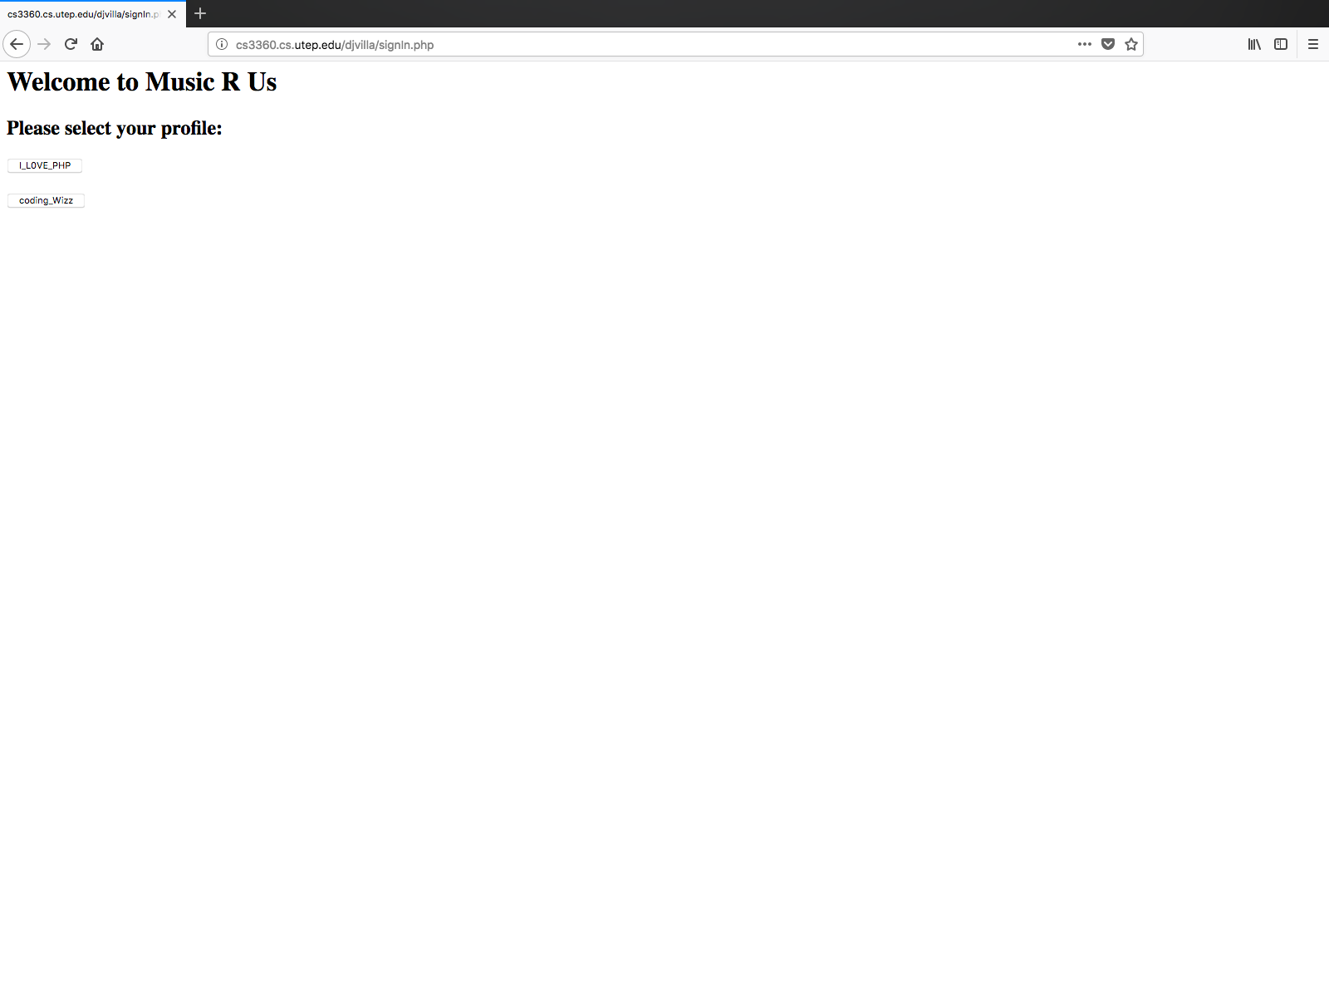

Figure 1 Multiple Users

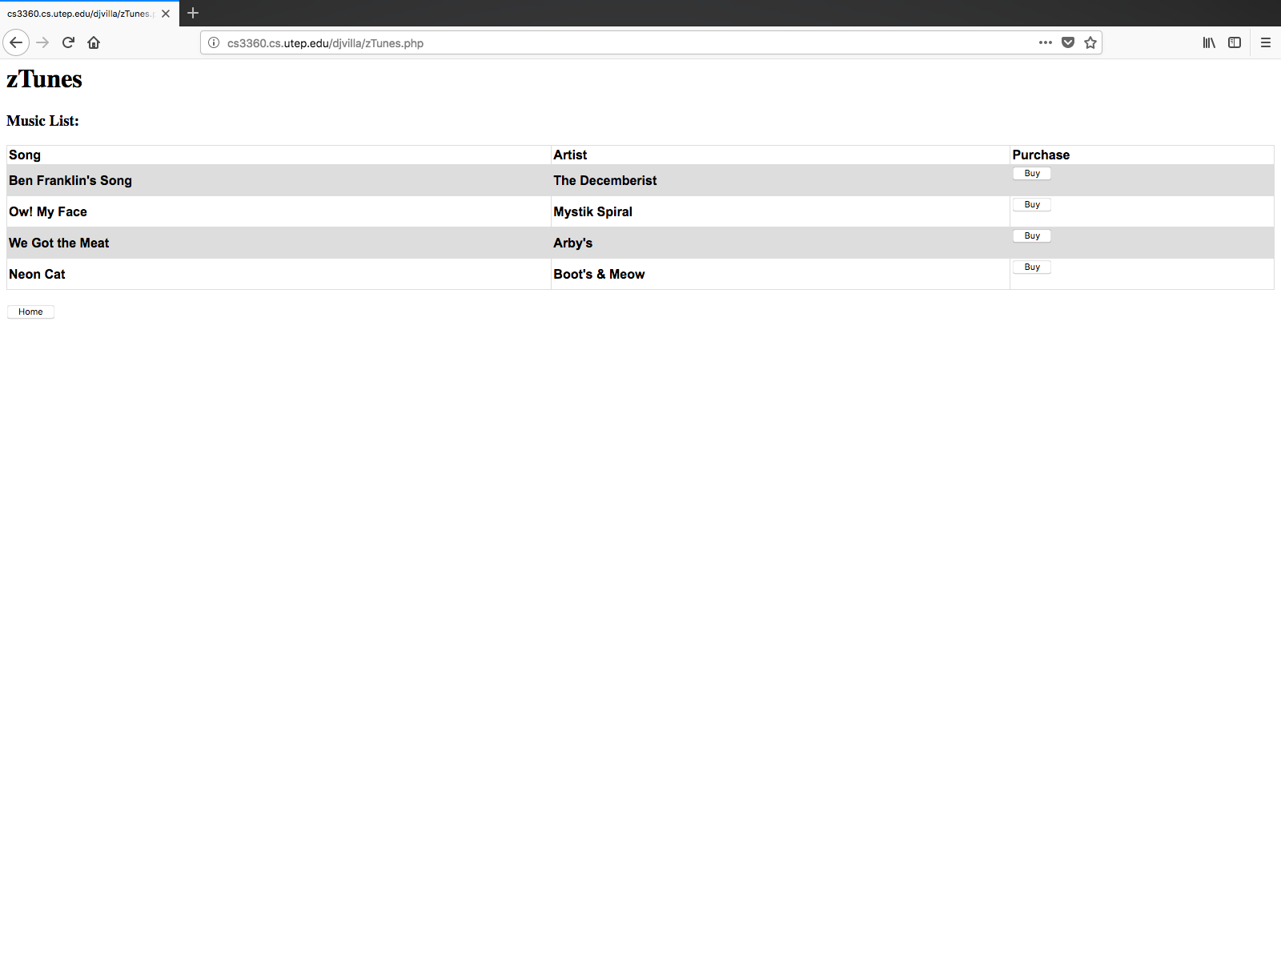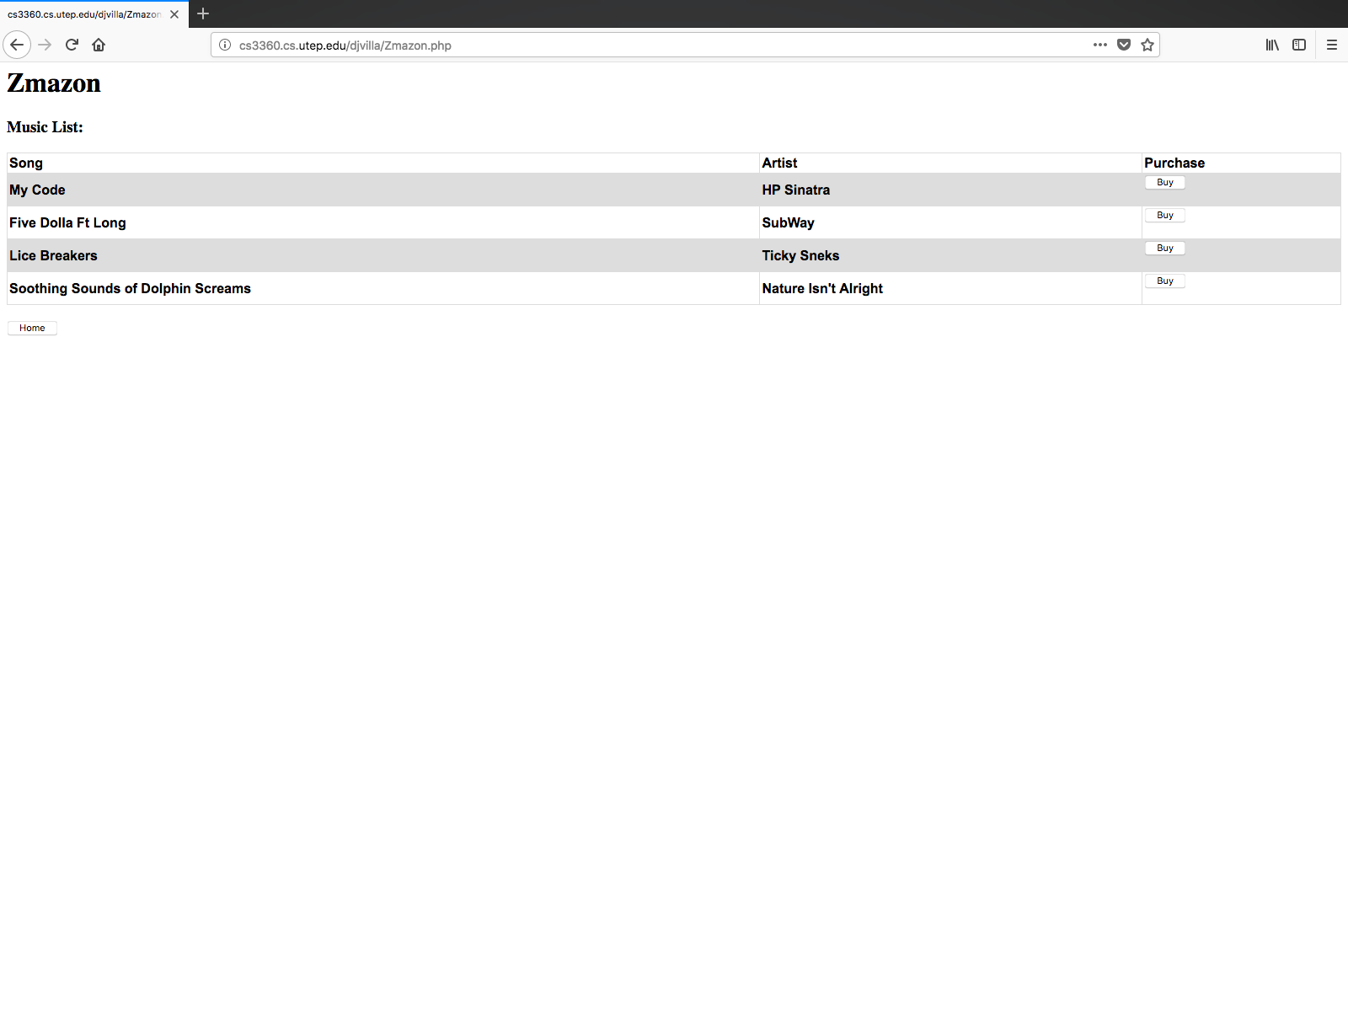

Figure 2 Two music sources with a list of song available for purchase

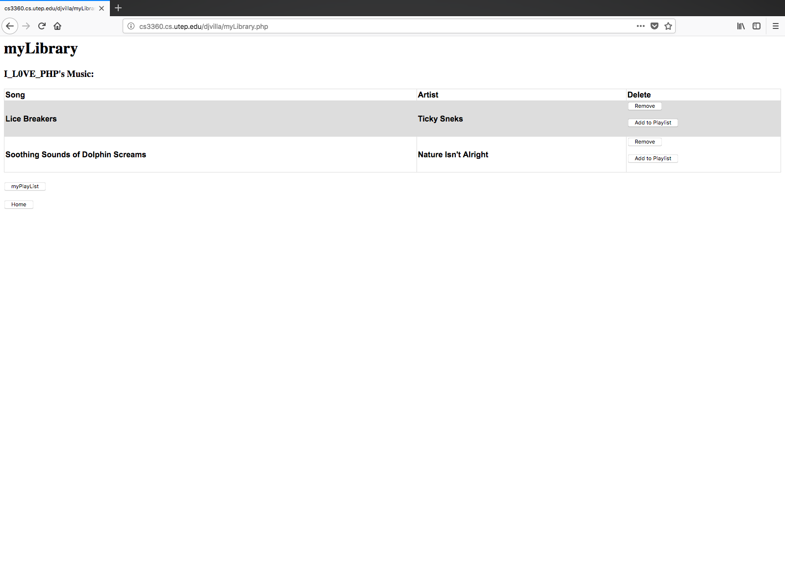

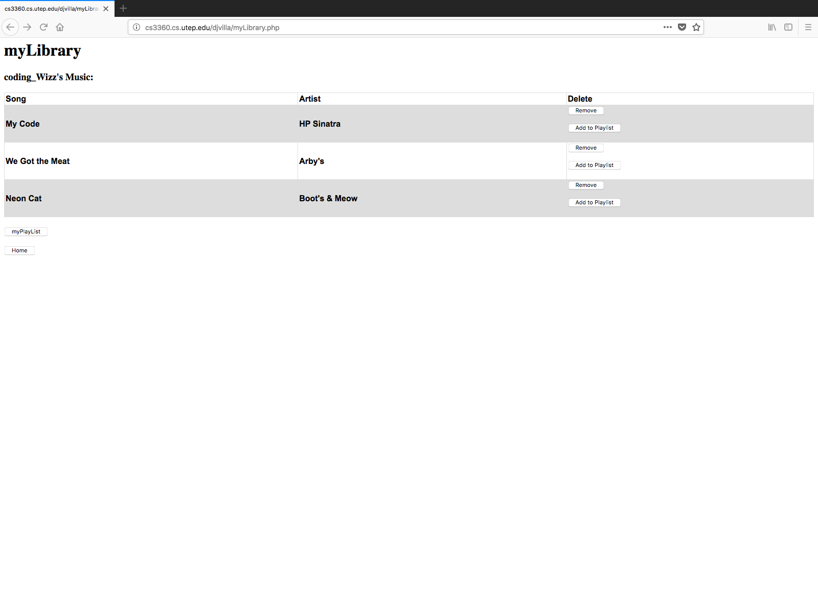

Figure 3 Multiple User’s Library showing buttons to remove songs and to add them to a playlist

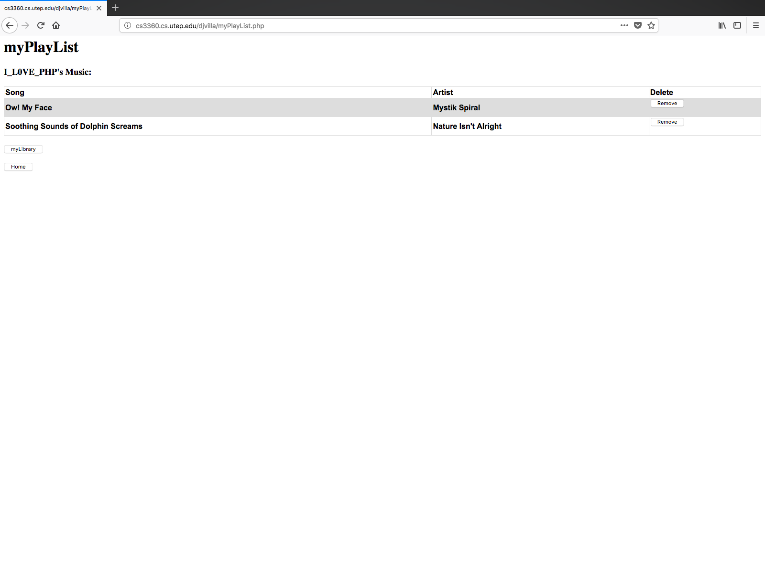

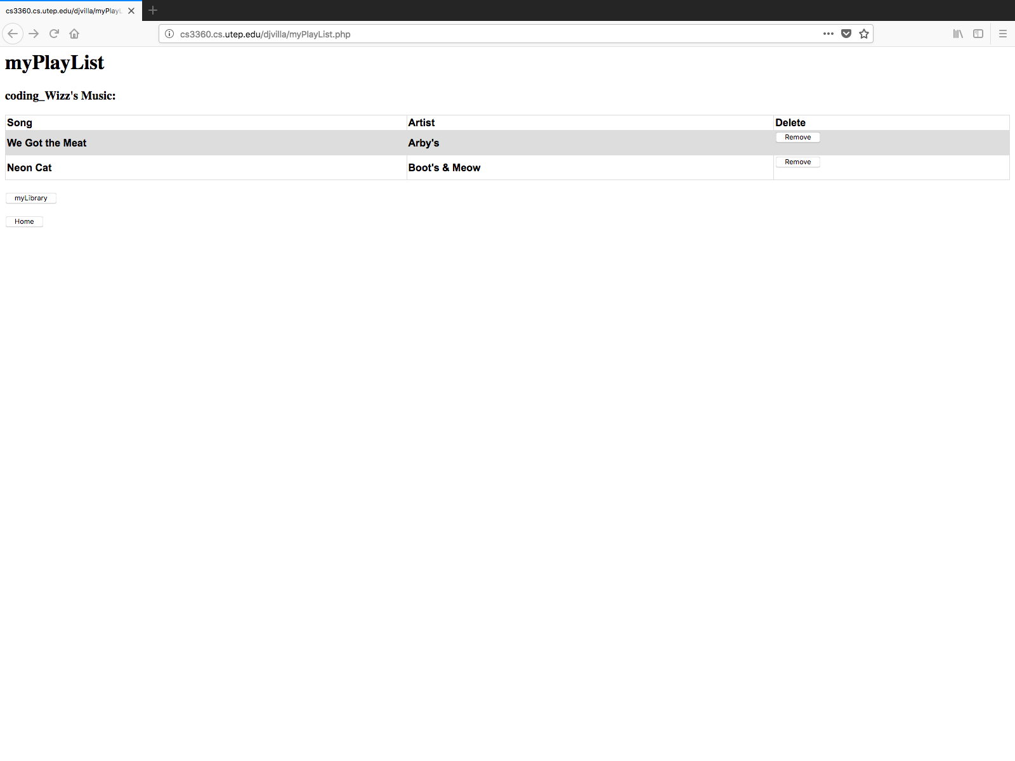

Figure 4 Multiple Users Playlist where songs are added and deleted

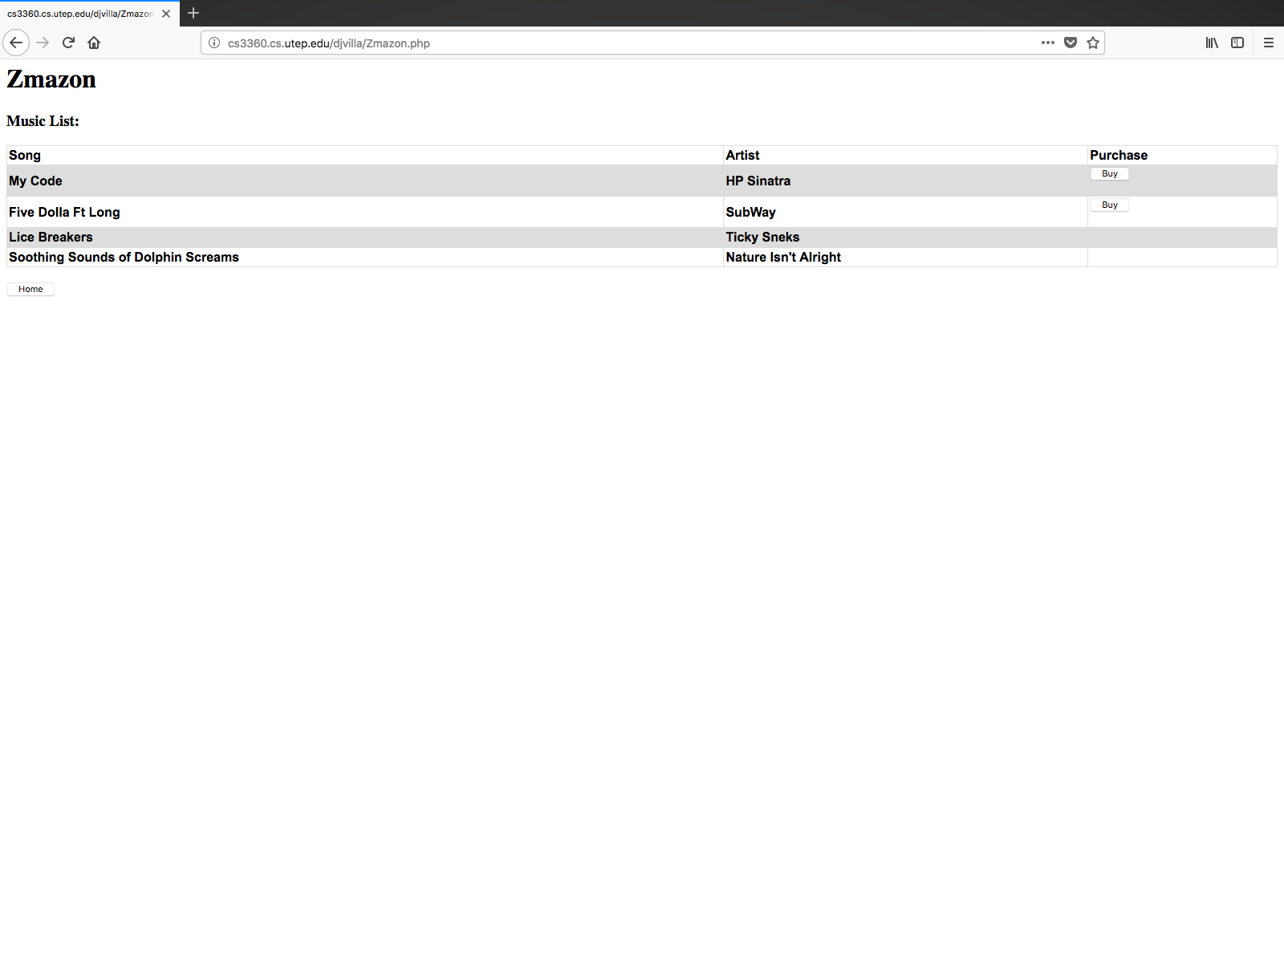

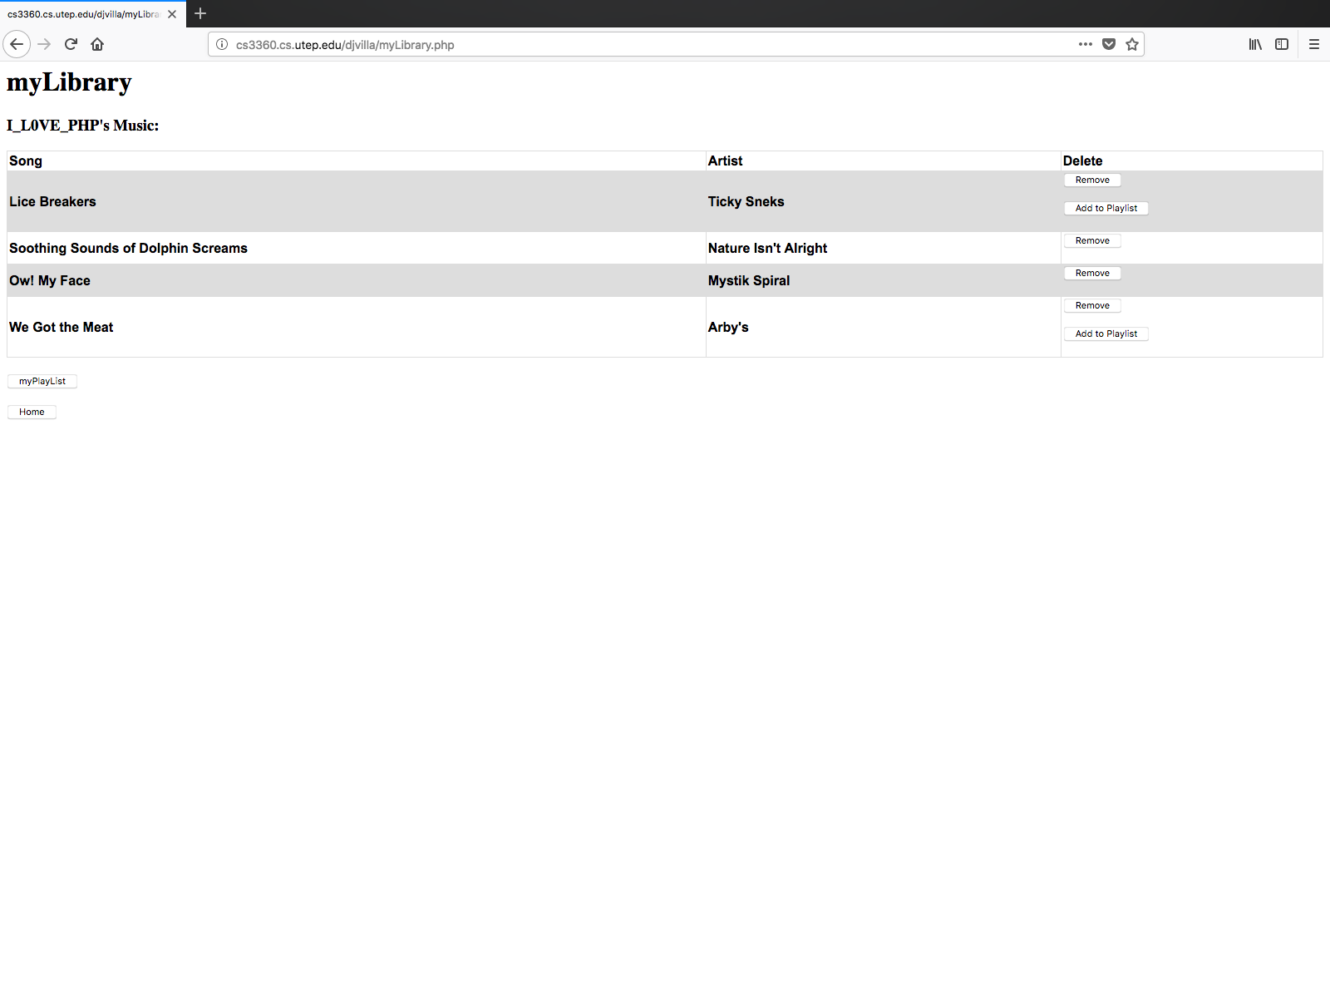

Figure 5 Store and Library were buttons disappear to prevent multiple purchases and additions to the playlist

1. **Code:**

* **signIn.php**

<html>

<body>

<h1>Welcome to Music R Us</h1>

<h2>Please select your profile:<h2>

<!-- Create Array to store users info Song List -->

<?php

//Start the session. If a new session, create the arrays to hold the song and artist and playlist

session_start();

if(empty($_SESSION['user1']['songsAdded'])){

$_SESSION['user1']['songsAdded'] = array();

$_SESSION['user1']['artistAdded'] = array();

$_SESSION['user1']['playlistSongs'] = array();

$_SESSION['user1']['playlistArtist'] = array();

}

if(empty($_SESSION['user2']['songsAdded'])){

$_SESSION['user2']['songsAdded'] = array();

$_SESSION['user2']['artistAdded'] = array();

$_SESSION['user2']['playlistSongs'] = array();

$_SESSION['user2']['playlistArtist'] = array();

}

//USer is set to be signed off when they enter this page

$_SESSION['user1']['signIn']= 0;

$_SESSION['user2']['signIn']= 0;

?>

<!--Click button to go to zTunes-->

<?php

//Button for user1 to sign in

if (!empty($_GET["user1"])){

$_SESSION['user1']['signIn']= 1;

header('Location: homeSite.php');

}else{

echo "<form action=\"signIn.php\" method=get>

<input type=\"submit\" name=user1 value=\"I_L0VE_PHP\" />

</form>

</th></tr>";

}

//button for user2 to sign in

if (!empty($_GET["user2"])){

$_SESSION['user2']['signIn']= 1;

header('Location: homeSite.php');

}else{

echo "<form action=\"signIn.php\" method=get>

<input type=\"submit\" name=user2 value=\"coding_Wizz\" />

</form>

</th></tr>";

}

?>

</body>

</html>

* **homeSite.php**

<html>

<body>

<h1>Music R Us</h1>

<?php

//Start the session. If a new session, create the arrays to hold the song and artist

session_start();

if ($_SESSION['user1']['signIn'] ==1){

echo "<h2>Welcome I_L0VE_PHP</h2>";

}

if ($_SESSION['user2']['signIn'] ==1){

echo "<h2>Welcome coding_Wizz";

}

?>

<h2>Please select what you want to do:</h2>

<!--Click button to go to zTunes-->

<form action="zTunes.php", method=post>

<input type="submit" value="zTunes">

</form>

<!--Click button to go to Zmazon-->

<form action="Zmazon.php", method=post>

<input type="submit" value="Zmazon">

</form>

<!--Click button to go to myLibrary-->

<form action="myLibrary.php", method=post>

<input type="submit" value="myLibrary">

</form>

<!--Click button to go to myPlayList-->

<form action="myPlayList.php", method=post>

<input type="submit" value="myPlayList">

</form>

<!--Click button to go to signIn-->

<form action="signIn.php", method=post>

<input type="submit" value="Go back to Choose a Profile">

</form>

</body>

</html>

* **zTunes.php**

<html>

<head>

<!--Start session to access arrays and set which user is logged in-->

<?php

session_start();

//Check to see who to sign in so we can store their songs

if ($_SESSION['user1']['signIn'] ==1){

$q = 1;

}

if ($_SESSION['user2']['signIn'] ==1){

$q = 2;

}

?>

<!--Create style for the table to display songs to buy-->

<style>

table {

font-family: arial, sans-serif;

border-collapse: collapse;

width: 100%;

}

td, th {

border: 1px solid #dddddd;

text-align: left;

padding: 2px;

}

tr:nth-child(even) {

background-color: #dddddd;

}

</style>

</head>

<body>

<h1>zTunes</h1>

<h3>Music List:</h3>

<!--Build Table-->

<table>

<tr>

<th>Song</th>

<th>Artist</th>

<th>Purchase</th>

</tr>

<tr>

<th>Ben Franklin's Song</th>

<th>The Decemberist</th>

<th>

<?php

//If button is clicked

if (!empty($_GET['Tsong1'])){

$song = "Ben Franklin's Song";

$artist = "The Decemberist";

array_push($_SESSION["user$q"]['songsAdded'], $song);

array_push($_SESSION["user$q"]['artistAdded'], $artist);

}

//If song is already in the library, hide button. Else, show the button.

if(in_array("Ben Franklin's Song", $_SESSION["user$q"]['songsAdded'])) {

echo "<form action=\"zTunes.php\" method=get>

<input type=\"hidden\" name=Tsong1 value=\"Owned\">

</form>";

}else{

echo "<form action=\"zTunes.php\" method=get>

<input type=\"submit\" name=Tsong1 value=\"Buy\" />

</form>";

}

?>

</th>

</tr>

<tr>

<th>Ow! My Face</th>

<th>Mystik Spiral</th>

<th>

<?php

//If button is clicked

if (!empty($_GET['Tsong2'])){

$song = "Ow! My Face";

$artist = "Mystik Spiral";

array_push($_SESSION["user$q"]['songsAdded'], $song);

array_push($_SESSION["user$q"]['artistAdded'], $artist);

}

//If song is already in the library, hide button. Else, show the button.

if(in_array("Ow! My Face", $_SESSION["user$q"]['songsAdded'])) {

echo "<form action=\"zTunes.php\" method=get>

<input type=\"hidden\" name=Tsong2 value=\"Owned\">

</form>";

}else{

echo "<form action=\"zTunes.php\" method=get>

<input type=\"submit\" name=Tsong2 value=\"Buy\" />

</form>";

}

?>

</th>

</tr>

<tr>

<th>We Got the Meat</th>

<th>Arby's</th>

<th>

<?php

//If button is clicked

if (!empty($_GET['Tsong3'])){

$song = "We Got the Meat";

$artist = "Arby's";

array_push($_SESSION["user$q"]['songsAdded'], $song);

array_push($_SESSION["user$q"]['artistAdded'], $artist);

}

//If song is already in the library, hide button. Else, show the button.

if(in_array("We Got the Meat", $_SESSION["user$q"]['songsAdded'])) {

echo "<form action=\"zTunes.php\" method=get>

<input type=\"hidden\" name=Tsong3 value=\"Owned\">

</form>";

}else{

echo "<form action=\"zTunes.php\" method=get>

<input type=\"submit\" name=Tsong3 value=\"Buy\" />

</form>";

}

?>

</th>

</tr>

<tr>

<th>Neon Cat</th>

<th>Boot's & Meow</th>

<th>

<?php

//If button is clicked

if (!empty($_GET['Tsong4'])){

$song = "Neon Cat";

$artist = "Boot's & Meow";

array_push($_SESSION["user$q"]['songsAdded'], $song);

array_push($_SESSION["user$q"]['artistAdded'], $artist);

}

//If song is already in the library, hide button. Else, show the button.

if(in_array("Neon Cat", $_SESSION["user$q"]['songsAdded'])) {

echo "<form action=\"zTunes.php\" method=get>

<input type=\"hidden\" name=Tsong4 value=\"Owned\">

</form>";

}else{

echo "<form action=\"zTunes.php\" method=get>

<input type=\"submit\" name=Tsong4 value=\"Buy\" />

</form>";

}

?>

</th>

</tr>

</table>

<!--Display go to home button-->

<br>

<form action="homeSite.php", method=post>

<input type="submit" value="Home">

</form>

</body>

</html>

* **Zmazon.php**

<html>

<head>

<!--Start session to access arrays and set which user is logged in-->

<?php

session_start();

if ($_SESSION['user1']['signIn'] ==1){

$q = 1;

}

if ($_SESSION['user2']['signIn'] ==1){

$q = 2;

}

?>

<!--Create style for the table to display songs to buy-->

<style>

table {

font-family: arial, sans-serif;

border-collapse: collapse;

width: 100%;

}

td, th {

border: 1px solid #dddddd;

text-align: left;

padding: 2px;

}

tr:nth-child(even) {

background-color: #dddddd;

}

</style>

</head>

<body>

<h1>Zmazon</h1>

<h3>Music List:</h3>

<!--Build Table-->

<table>

<tr>

<th>Song</th>

<th>Artist</th>

<th>Purchase</th>

</tr>

<tr>

<th>My Code</th>

<th>HP Sinatra</th>

<th>

<?php

//If button is clicked

if (!empty($_GET['Zsong1'])){

$song = "My Code";

$artist = "HP Sinatra";

array_push($_SESSION["user$q"]['songsAdded'], $song);

array_push($_SESSION["user$q"]['artistAdded'], $artist);

}

//If song is already in the library, hide button. Else, show the button.

if(in_array("My Code", $_SESSION["user$q"]['songsAdded'])) {

echo "<form action=\"Zmazon.php\" method=get>

<input type=\"hidden\" name=Zsong1 value=\"Owned\">

</form>";

}else{

echo "<form action=\"Zmazon.php\" method=get>

<input type=\"submit\" name=Zsong1 value=\"Buy\" />

</form>";

}

?>

</th>

</tr>

<tr>

<th>Five Dolla Ft Long</th>

<th>SubWay</th>

<th>

<?php

//If button is clicked

if (!empty($_GET['Zsong2'])){

$song = "Five Dolla Ft Long";

$artist = "SubWay";

array_push($_SESSION["user$q"]['songsAdded'], $song);

array_push($_SESSION["user$q"]['artistAdded'], $artist);

}

//If song is already in the library, hide button. Else, show the button.

if(in_array("Five Dolla Ft Long", $_SESSION["user$q"]['songsAdded'])) {

echo "<form action=\"Zmazon.php\" method=get>

<input type=\"hidden\" name=Zsong2 value=\"Owned\">

</form>";

}else{

echo "<form action=\"Zmazon.php\" method=get>

<input type=\"submit\" name=Zsong2 value=\"Buy\" />

</form>";

}

?>

</th>

</tr>

<tr>

<th>Lice Breakers</th>

<th>Ticky Sneks</th>

<th>

<?php

//If button is clicked

if (!empty($_GET['Zsong3'])){

$song = "Lice Breakers";

$artist = "Ticky Sneks";

array_push($_SESSION["user$q"]['songsAdded'], $song);

array_push($_SESSION["user$q"]['artistAdded'], $artist);

}

//If song is already in the library, hide button. Else, show the button.

if(in_array("Lice Breakers", $_SESSION["user$q"]['songsAdded'])) {

echo "<form action=\"Zmazon.php\" method=get>

<input type=\"hidden\" name=Zsong3 value=\"Owned\">

</form>";

}else{

echo "<form action=\"Zmazon.php\" method=get>

<input type=\"submit\" name=Zsong3 value=\"Buy\" />

</form>";

}

?>

</th>

</tr>

<tr>

<th>Soothing Sounds of Dolphin Screams</th>

<th>Nature Isn't Alright</th>

<th>

<?php

//If button is clicked

if (!empty($_GET['Zsong4'])){

$song = "Soothing Sounds of Dolphin Screams";

$artist = "Nature Isn't Alright";

array_push($_SESSION["user$q"]['songsAdded'], $song);

array_push($_SESSION["user$q"]['artistAdded'], $artist);

}

//If song is already in the library, hide button. Else, show the button.

if(in_array("Soothing Sounds of Dolphin Screams", $_SESSION["user$q"]['songsAdded'])) {

echo "<form action=\"Zmazon.php\" method=get>

<input type=\"hidden\" name=Zsong4 value=\"Owned\">

</form>";

}else{

echo "<form action=\"Zmazon.php\" method=get>

<input type=\"submit\" name=Zsong4 value=\"Buy\" />

</form>";

}

?>

</th>

</tr>

</table>

<!--Display go to home button-->

<br>

<form action="homeSite.php", method=post>

<input type="submit" value="Home">

</form>

</body>

</html>

* **myLibrary.php**

<html>

<head>

<!--Start session to access arrays and set which user is logged in-->

<?php

session_start();

if ($_SESSION['user1']['signIn'] ==1){

$q = 1;

}

if ($_SESSION['user2']['signIn'] ==1){

$q = 2;

}

?>

<!--Create style for the table to display songs in library, if any-->

<style>

table {

font-family: arial, sans-serif;

border-collapse: collapse;

width: 100%;

}

td, th {

border: 1px solid #dddddd;

text-align: left;

padding: 2px;

}

tr:nth-child(even) {

background-color: #dddddd;

}

</style>

</head>

<body>

<!--Display Headings-->

<h1>myLibrary</h1>

<?php

if ($_SESSION['user1']['signIn'] ==1){

echo "<h3>I_L0VE_PHP's Music: <h3>";

}

if ($_SESSION['user2']['signIn'] ==1){

echo "<h3>coding_Wizz's Music: <h3>";

}

?>

<!--Build Table-->

<table>

<tr>

<th>Song</th>

<th>Artist</th>

<th>Delete</th>

</tr>

<?php

//If the song list is not empty, generate a graph

if(isset($_SESSION["user$q"]['songsAdded']) && !empty($_SESSION["user$q"]['songsAdded'])) {

for ($x = 0; $x <= count($_SESSION["user$q"]['songsAdded'])-1; $x++){

echo "<tr><th>". $_SESSION["user$q"]['songsAdded'][$x] ."

<th>". $_SESSION["user$q"]['artistAdded'][$x] ."</th>

<th>";

//If the button is pressed, save index and move to delete site, else display button

if (!empty($_GET["MYsong$x"])){

$_SESSION["index"] = $x;

header('Location: deleteSong.php');

}else {

echo "<form action=\"myLibrary.php\" method=get>

<input type=\"submit\" name=MYsong$x value=\"Remove\" />

</form>";

}

if (!empty($_GET["AddMYsong$x"])){

$song = $_SESSION["user$q"]['songsAdded'][$x];

$artist = $_SESSION["user$q"]['artistAdded'][$x];

array_push($_SESSION["user$q"]['playlistSongs'], $song);

array_push($_SESSION["user$q"]['playlistArtist'], $artist);

}

if(in_array($_SESSION["user$q"]['songsAdded'][$x], $_SESSION["user$q"]['playlistSongs'])) {

echo "<form action=\"myLibrary.php\" method=get>

<input type=\"hidden\" name=AddMYsong$x value=\"Owned\">

</form>

</th></tr>";

}else {

echo "<form action=\"myLibrary.php\" method=get>

<input type=\"submit\" name=AddMYsong$x value=\"Add to Playlist\" />

</form>

</th></tr>";

}

}

}

?>

</table>

<br>

<!--Click button to go to myPlayList-->

<form action="myPlayList.php", method=post>

<input type="submit" value="myPlayList">

</form>

<!--Display go to home button-->

<form action="homeSite.php", method=post>

<input type="submit" value="Home">

</form>

<!--Debugging-->

<?php

//var_dump($_SESSION);

?>

</body>

</html>

* **deleteSong.php**

<html>

<body>

<!--Start session to access arrays and set which user is logged in-->

<?php

session_start();

if ($_SESSION['user1']['signIn'] ==1){

$q = 1;

}

if ($_SESSION['user2']['signIn'] ==1){

$q = 2;

}

?>

<h1>myLibrary</h1>

<h3>Song Successfully Removed: <h3>

<?php

$x = $_SESSION["index"];

$song = $_SESSION["user$q"]['songsAdded'][$x];

$artist = $_SESSION["user$q"]['artistAdded'][$x];

$_SESSION["user$q"]['songsAdded'] = array_diff($_SESSION["user$q"]['songsAdded'], array($song));

$_SESSION["user$q"]['artistAdded'] = array_diff($_SESSION["user$q"]['artistAdded'], array($artist));

$_SESSION["user$q"]['songsAdded'] = array_values($_SESSION["user$q"]['songsAdded']);

$_SESSION["user$q"]['artistAdded'] = array_values($_SESSION["user$q"]['artistAdded']);

?>

<!--Click button to go to myLibrary-->

<br>

<form action="myLibrary.php", method=post>

<input type="submit" value="Return to myLibrary">

</form>

<!--Click button to go to homeSite-->

<form action="homeSite.php", method=post>

<input type="submit" value="Return Home">

</form>

</body>

</html>

* **myPlayList.php**

<html>

<head>

<!--Start session to access arrays and set which user is logged in-->

<?php

session_start();

if ($_SESSION['user1']['signIn'] ==1){

$q = 1;

}

if ($_SESSION['user2']['signIn'] ==1){

$q = 2;

}

?>

<!--Create style for the table to display songs in library, if any-->

<style>

table {

font-family: arial, sans-serif;

border-collapse: collapse;

width: 100%;

}

td, th {

border: 1px solid #dddddd;

text-align: left;

padding: 2px;

}

tr:nth-child(even) {

background-color: #dddddd;

}

</style>

</head>

<body>

<!--Display Headings-->

<h1>myPlayList</h1>

<?php

if ($_SESSION['user1']['signIn'] ==1){

echo "<h3>I_L0VE_PHP's Music: <h3>";

}

if ($_SESSION['user2']['signIn'] ==1){

echo "<h3>coding_Wizz's Music: <h3>";

}

?>

<!--Build Table-->

<table>

<tr>

<th>Song</th>

<th>Artist</th>

<th>Delete</th>

</tr>

<?php

//If the song list is not empty, generate a graph

if(isset($_SESSION["user$q"]['songsAdded']) && !empty($_SESSION["user$q"]['songsAdded'])) {

for ($x = 0; $x <= count($_SESSION["user$q"]['playlistSongs'])-1; $x++){

echo "<tr><th>". $_SESSION["user$q"]['playlistSongs'][$x] ."

<th>". $_SESSION["user$q"]['playlistArtist'][$x] ."</th>

<th>";

//If the button is pressed, save index and move to delete site, else display button

if (!empty($_GET["MYsong$x"])){

$_SESSION["index"] = $x;

header('Location: deleteList.php');

}else {

echo "<form action=\"myPLayList.php\" method=get>

<input type=\"submit\" name=MYsong$x value=\"Remove\" />

</form>

</th></tr>";

}

}

}

?>

</table>

<br>

<!--Click button to go to myLibrary-->

<form action="myLibrary.php", method=post>

<input type="submit" value="myLibrary">

</form>

<!--Display go to home button-->

<form action="homeSite.php", method=post>

<input type="submit" value="Home">

</form>

<!--Debugging-->

<?php

//var_dump($_SESSION);

?>

</body>

</html>

* **deleteList.php**

<html>

<body>

<!--Start session to access arrays and set which user is logged in-->

<?php

session_start();

if ($_SESSION['user1']['signIn'] ==1){

$q = 1;

}

if ($_SESSION['user2']['signIn'] ==1){

$q = 2;

}

?>

<h1>myPlayList</h1>

<h3>Song Successfully Removed: <h3>

<?php

$x = $_SESSION["index"];

$song = $_SESSION["user$q"]['playlistSongs'][$x];

$artist = $_SESSION["user$q"]['playlistArtist'][$x];

$_SESSION["user$q"]['playlistSongs'] = array_diff($_SESSION["user$q"]['playlistSongs'], array($song));

$_SESSION["user$q"]['playlistArtist'] = array_diff($_SESSION["user$q"]['playlistArtist'], array($artist));

$_SESSION["user$q"]['playlistSongs'] = array_values($_SESSION["user$q"]['playlistSongs']);

$_SESSION["user$q"]['playlistArtist'] = array_values($_SESSION["user$q"]['playlistArtist']);

?>

<!--Click button to go to myLibrary-->

<br>

<form action="myPlayList.php", method=post>

<input type="submit" value="Return to myPlayList">

</form>

<!--Click button to go to myLibrary-->

<form action="myLibrary.php", method=post>

<input type="submit" value="Return to myLibrary">

</form>

<!--Click button to go to homeSite-->

<form action="homeSite.php", method=post>

<input type="submit" value="Return Home">

</form>

</body>

</html>

1. Is my code object orientated?

If arrays count as objects in php, then my whole program is object orientated. I use arrays to determine what user is logged in, which user added songs to their library and their playlist, which songs they remove, what songs are on the store. Everything that moves from one page to another is inside an array. The problem with this is if I forgot to add something to one array, everything else comes out wrong. I have to keep track of what gets added into the array and what doesn’t.

1. **Example of the unusual properties of PHP:**

The properties of PHP didn’t allow me to delete the songs off of the library correctly. They would be deleted out of the array holding the user’s songs, but when it had to be displayed, it would either display the only song that got deleted or not do anything at all unless you leave the page and come back. To fix this, I redirected to another page that deleted the song the user wanted to, then came back to the library to redraw the table. This allowed me to show what was actually on the graph and remove the song easily.